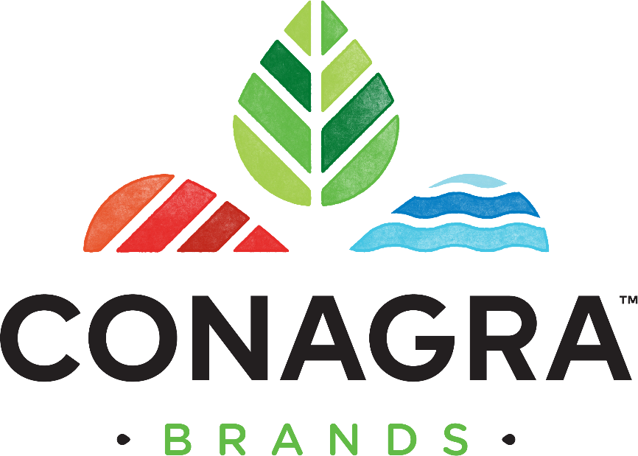

CONAGRA BRANDS INC. GUIDELINES TO SUPPORT TIMELY PAYMENT

OF SUPPLIER INVOICES
Updated March 2024

TABLE OF CONTENTS
- PURPOSE OF THIS DOCUMENT 2
- UNDERSTAND CONAGRA BRANDS’ REQUIREMENTS 2
  - HOW DO WE BUY FROM OUR SUPPLIERS? 2
  - WHICH CONAGRA BRANDS ENTITY SHOULD I INVOICE IN TUNGSTEN? 2
  - HOW DO WE PROCESS SUPPLIER INVOICES? 3
- TIPS & TRICKS FOR FAST INVOICE PROCESSING & PAYMENT 3
  - KNOW YOUR PURCHASE ORDER (PO) NUMBER 3
  - WHAT IF MY INVOICE WAS REJECTED BY TUNGSTEN? 4
  - HOW DO I CHECK THE STATUS OF AN INVOICE? 4
  - WHAT DO THE TUNGSTEN NETWORK INVOICE STATUSES MEAN? 4
  - WHAT DO THE CONAGRA BRANDS INVOICE STATUSES MEAN? 4
  - WHERE WILL I FIND PAYMENT DETAILS? 4

PURPOSE OF THIS DOCUMENT
Conagra Brands utilizes the Tungsten Network e-Invoicing platform to improve the invoicing and payment experience with our suppliers. These benefits include increased accuracy, reduced re- work, and improved supplier visibility to invoice and payment statuses. This guide will assist our suppliers to ensure that:
- Invoices successfully pass through the automated validation steps at Tungsten Network and reach Conagra Brands within minutes after submission
- Invoices contain all information required for fast processing and approval
- Suppliers know what to do with the information given to them regarding the status of their invoice(s)

UNDERSTAND CONAGRA BRANDS’ REQUIREMENTS

HOW DO WE BUY FROM OUR SUPPLIERS?
As a best practice, suppliers receive a Purchase Order (PO) number at the time of purchase made by Conagra Brands. In the event a PO number is not provided (Non PO), suppliers will need to note the Conagra contact name and email address of the Conagra Brands employee that made the purchase on the invoice.

Purchase order (PO) numbers could be distributed from one or a combination of the following entities:
    - Conagra Foods Mexico
    - CFM Admin de Pers S de RL

Note: At this time, all purchases will continue to be made through the existing methods and systems.

WHICH CONAGRA BRANDS ENTITY SHOULD I INVOICE IN TUNGSTEN?

2.2 WHICH CONAGRA BRANDS ENTITY SHOULD I INVOICE IN TUNGSTEN?
Tungsten AAA Account ID | Tungsten AAA Account Name | Company Code | Purchase Order Structure | Purchase Order Submission Requirements
AAA459614558 | ConAgra Foods Mexico | 2545 | 6 digits, all numeric beginning with '1'; 00001xxxxx | PO must contain all 6 numeric digits beginning with '1'; 00001xxxxx
AAA801702796 | CFM Admin de Pers S de RL | 2560 | Non PO (2.1) | Non PO (2.1)

HOW DO WE PROCESS SUPPLIER INVOICES?
Tungsten Network runs a series of validation steps on each invoice submitted by our suppliers to ensure compliance and accuracy. Following the rules below will allow invoices to pass through all validation and matching steps in a timely manner. It will also enable on-time payment by ensuring invoices avoid rejection and rework.

Invoices must follow these guidelines to be accepted by Conagra Brands:

- Identify the correct Tungsten Network AAA# to invoice against based on the Purchase Order (PO) structure [see section 2.2]
- Invoice number no longer than 16 digits – invoice numbers cannot be reused
- Valid Purchase Order (PO) number
  - If a PO number is not available, the invoice must contain a valid Conagra Brands employee contact name and email address
- Ship-to address, including City, State/Province, and Postal Code
- Line Item details must exactly match the corresponding PO, including but not limited to:
  - Type of Product / Material Name
  - Material Number
  - Description (including the WBS element, if provided)
  - Unit of Measure
  - Price
  - Quantity
  - Currency
  - Payment Terms
- Any attachment(s) must be provided as a PDF document (no more than 10 will be accepted at one time)
Note: When providing a credit note please reference the original invoice number and Purchase Order (PO) number the credit note applies to.

There are certain validation steps that can only be performed once an invoice has been submitted. Therefore, please use the Tungsten Network portal to check the status of your invoices on a regular basis and resubmit any failed invoices/credits once corrected [see sections 3.2, 3.3, 3.4 and 3.5].

If an invoice is not 100% accurate, it will be directed to an Accounts Payable specialist for resolution. The specialist will review and work with you and the appropriate Conagra Brands employee to bring the invoice to a satisfactory state. When the invoice matches the Purchase Order 100% and your due date based on contracted payment terms has arrived, it will be released for payment according to the payment method on file with Accounts Payable. [see section 3.6].

TIPS & TRICKS FOR FAST INVOICE PROCESSING & PAYMENT

KNOW YOUR PURCHASE ORDER (PO) NUMBER
Please make sure that, when possible, you receive a Purchase Order (PO) number for every order and that you provide it when billing the corresponding entity. If a PO number is not provided, your invoice must contain a valid Conagra Brands’ employee contact name and email address. (2.1)

WHAT IF MY INVOICE WAS REJECTED BY TUNGSTEN?
It is important to make sure that your invoice is compliant with the requirements listed in section 2.3. Please use the following links to learn more about ways to receive assistance:

- What to do if my invoice fails? (site.com)
- How to contact our Support and get assistance? (site.com)https://www.tungsten-network.com/us/support/tutorials/?video=find-help-and-support-on-the-tungsten-network-portal
- How to check the status of your invoices? (site.com)

HOW DO I CHECK THE STATUS OF AN INVOICE?
As a member of the Tungsten Network you will have access to view the status of your invoice(s) via the Tungsten Network portal. Invoice Status gives you the ability to view the status of your invoices individually or as an overview. For further detail view the video found at this link.

WHAT DO THE TUNGSTEN NETWORK INVOICE STATUSES MEAN?
The following statuses apply to invoices sent to all Tungsten Network AAA# listed in section 2.2:

- Sent: This status only applies to invoices submitted via the 'Create invoice' page. Once sent, the invoice is registered and will display this status until it is processed
- Accepted: The invoice has been processed successfully and is awaiting delivery to Conagra Brands.
- Failed: The invoice has failed validation. This is most commonly caused by a processing error or missing data that is required by the system, country or Conagra Brands.
- Exception: Conagra Brands has indicated that there may be a problem with the invoice, which it is investigating. If Conagra Brands has provided more information, you will find it in the invoice status area when you review this invoice
- Delivered: The invoice has been successfully delivered to Conagra Brands.

WHAT DO THE CONAGRA BRANDS INVOICE STATUSES MEAN?
The following statuses apply to invoices sent to Tungsten Network AAA459614558 or AAA801702796 for Conagra ONLY:
- Received: Conagra Brands received the invoice and has initiated the approval review process.
- Approved: Conagra Brands has approved your invoice for payment. The invoice will be released for payment when your due date based on contracted payment terms has arrived.
- On Hold: Your invoice is on hold pending a standard invoice approval task.
- Exception: Your invoice requires additional approval within Conagra Brands.
- Paid: Conagra Brands has paid your invoice or marked the invoice for payment.
- Rejected: Conagra Brands has rejected your invoice.

WHERE WILL I FIND PAYMENT DETAILS?
Payment methods and remittance details will remain in the current format that exists between the supplier and Conagra Brands. For any payment issues that cannot be resolved by utilizing the Tungsten Network portal, please contact Conagra Accounts Payable.

